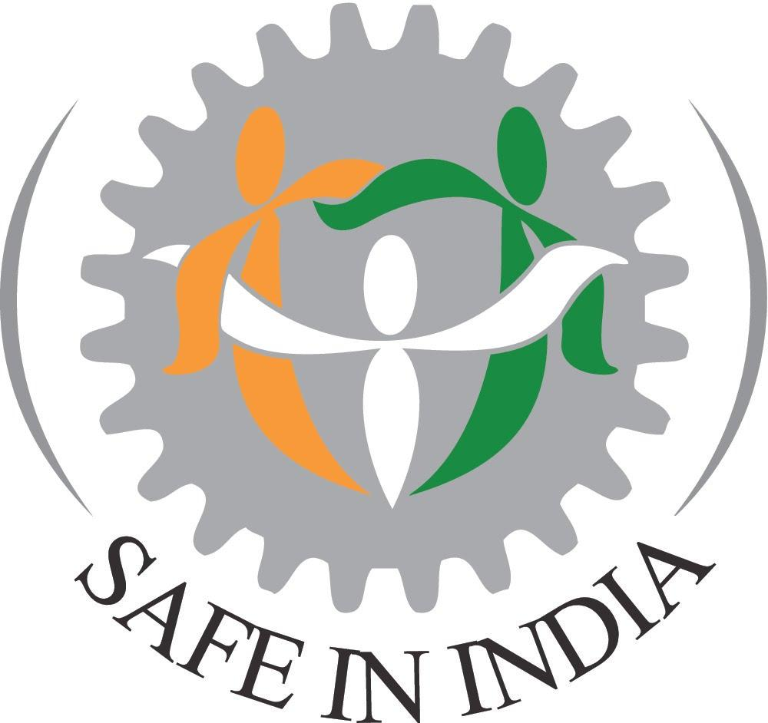

CIN: U74999HR2017NPL070537

**Press Release – 09th August 2024**

**Release of SafetyNiti 2024**

**Highlights**

1. Data from 1998 injured workers from Haryana & Maharashtra supported by SII in FY 23-24, of whom 1597 (80%) were from the automobile sector supply chain; most workers in Haryana made parts for **Maruti Suzuki (543 workers)** and most workers in **Maharashtra** made parts for Tata **(350 workers).**
2. Most of these injured workers are/were on contract, earning less than Rs. 15,000 per month, for mostly 12-hour shifts, 6 days a week, for these high-risk jobs, and two-thirds of them lost fingers and limbs.
3. Over the past four years, since SafetyNiti 2021, the most improved brands are **Bajaj and Honda**, while **Ashok Leyland and TVS** appear to have relatively been left behind.
4. The top 8 automobile brands listed in India have reported adequately on less than 40% of OSH indicators in **SEBI’s BRSR**
5. This document has links to the **videos** and **pictures** of the release event which includes a presentation on the report and two panel discussions – an injured workers’ panel and an expert panel with panellists from the **Ministry of Corporate Affairs, CIVIDEP India**, **Social Compact, Dasra**, and **Safe In India**.

Details below:

Safe In India Foundation (SII) released the 4th SafetyNiti report with data and insights from four years of tracking India’s top 10 automobile sector brands’ (**Ashok Leyland, Bajaj, Eicher, Hero, Honda, Hyundai, Mahindra, Maruti Suzuki, Tata, and TVS**) OSH (**Occupational Safety and Health**) policies for their supply chain on 9th August 2024 at India Habitat Centre, New Delhi.

A panel discussion with three workers injured in the automobile supply chain and an expert panel discussion with Dr Garima Dadhich, Associate Professor, IICA, **Ministry of Corporate Affairs**, Deepika Rao, Executive Director, **CIVIDEP India**, Sonvi Khanna, Associate Director, **Social Compact, Dasra**, and V N Saroja, Senior Advisor, **Safe In India**, moderated by Sandeep Sachdeva, Co-Founder & CEO, Safe In India were also conducted as part of the release.

This press release consists of the following sections (in order):

1. The Issue
2. SafetyNiti 2024 highlights
3. Quotes from the worker panellists, expert panellists, and the SII management
4. About SII and contact details

**Please find the full report here -** [**https://www.safeinindia.org/worker-safety-reports**](https://www.safeinindia.org/worker-safety-reports)

**Please find high-res pictures from the event here –** [**Pictures**](https://drive.google.com/drive/folders/1A6pmfdtqOl1HQ6Ol4Ky_2qmGqD5kPq5B)

**The Issue**

SII alone now finds **2000+ serious disabling injuries, annually**, in the auto component factories in only three districts in two states: likely a fraction of the total injuries nationally in suppliers of all the main automobile brands.

*2024-25 data is a projection

Most of these injured workers are/were on contract, earning less than Rs. 15,000 per month, for mostly 12-hour shifts, 6 days a week, for these high-risk jobs and 67% had lost a part of their body to the accident, changing their lives forever.

Please watch the 3-minute video below highlighting the impact of these injuries on women workers.

](https://www.youtube.com/watch?v=jae69dasFSs)

SII’s SafetyNiti 2024 focuses on answering questions on OSH policies of automobile brands, and action taken (and not) by automobile brands and other ecosystem players, including industry associations, non-financial auditors, investors, and the government and its agencies, like:

* What does data from 2000+ injured workers supported by SII in the past year (and 7000+ to date) inform about injuries and the state of worker safety in India's automobile sector?
* Have the top 10 automobile brands now declared to treat non-permanent workers and workers in their supplier factories the same as permanent in their worker safety policies? How are their overall policies and implementation?
* Is the new SEBI reporting requirement - BRSR (Business Responsibility and Sustainability Reporting) working well?
* Who are the top ESG auditors and domestic and international investors in the top 10 automobile brands? What is their responsibility?

**Some SafetyNiti 2024 highlights:**

1. **The issue of thousands of disabling injuries every year in the automobile brands’ supplier factories is a multi-brand and pan-India problem**

From 2016, SII has found and assisted 8,000+ injured workers, mainly in Haryana and Maharashtra where SII has field teams, of which 6,000+ were in the automobile sector.

Data collected for previous reports indicates that this issue is widespread in the other auto sector hubs, i.e., in Tamil Nadu, Karnataka, Uttarakhand and Rajasthan. (p.4)

1. **Two-thirds (67%) of these injuries result in a loss of body parts for the workers (FY 23-24).**

Extent of disabling injuries in automobile brands’ supplier factories

In 1,593 workers assisted by SII in FY23-24 from the automobile brands’ supplier factories in Haryana and Maharashtra; 1,073 workers (67%) lost body parts as a result of their injuries. (p.5)

1. **Most of these injured workers are/were on contract, earning less than Rs. 15,000 per month, for mostly 12-hour shifts, 6 days a week, for these high-risk jobs.**

Most (68%) of the 1,591 workers injured in the automobile brands’ supplier factories in Haryana and Pune, Maharashtra, for whom SII has data for FY 23-24 were contract workers.

86% of the 1,581 workers injured in the automobile brands’ supplier factories in Haryana and Maharashtra, for whom SII has data for FY 23-24, earned less than Rs. 15,000 per month six days a week, 12 hours a day for their high-risk jobs. Most report not being paid overtime at twice the rate per law. (p. 6)

1. **SafetyNiti reports on a continuing trend of improvements in OSH policy**A screenshot of a computer screen

   Description automatically generated

Since SafetyNiti2021, there has been an improvement in a few policy adoptions, with three of the top 10 brands, which were ranked at the bottom in SN23; Ashok Leyland, Hero, and TVS having adopted/published their Supplier Codes of Conduct – the document which advises suppliers of the automobile brands’ safety policies in the last one year. Please refer to Annexure 13 of SafetyNiti 2024 (p. 158) for a 4-year analysis.

1. **No significant improvements related to implementation of OSH in the supply chain**

No brand has taken any significant national corrective action for their deeper supply chain (training, audits & proactive actions). Only three brands (Bajaj, Maruti Suzuki, & Tata) monitor even their Tier 1 for even one of the following: appointment letters for workers, ESIC registration and accident and injury reporting.

Bajaj now relatively has the most complete set of documents and TVS the least of all the 10 automobile brands. Over the past four years, since SafetyNiti 2021, the most improved brands are Bajaj and Honda, while Ashok Leyland and TVS appear to have relatively been left behind. Please refer to Annexure 13 of SafetyNiti 2024 (p. 158) for a 4-year analysis.

1. **On average, the top 8 automobile brands listed in India have reported adequately on less than 40% of OSH indicators in SEBI’s BRSR**

SEBI’s non-financial reporting - Business Responsibility and Sustainability Reporting (BRSR) was compulsory for the top 1000 listed companies from 2022-23. SII analysed the eight brands on their OSH reporting in BRSR based on NSE’s sector-specific integrated guide to the BRSR format for the automobile sector. The brands could be graded as green (satisfactory) in only about 10 out of 28 (37%) indicators, amber (below satisfactory) in about six (21%) indicators and red (unsatisfactory) in about 12 (42%) indicators. Most brands had below satisfactory, and unsatisfactory scores for indicators related to awareness & training, grievance redressal, and corrective actions for their own factories and all indicators related to their supply chains. (p.93)

1. **Large unlisted companies (e.g., Honda and Hyundai) do not report India data on OSH anywhere**

SII has analysed the reporting by Honda and Hyundai (GRI and ESRS). Although, Honda and Hyundai may be measuring these indicators for India and reporting them under broader categories like “Overseas”, “India-Pacific” etc., they do not report on India-specific indicators related to OSH and human rights as well as other sustainability indicators in these reports.

Extending BRSR reporting requirements to huge unlisted privately held companies (e.g. Honda and Hyundai) is needed for a level playing field for listed companies in the same sector and to ensure that they too are accountable for improving working conditions in their Indian supply chain. (p. 87 & p.97)

1. **Audits and assurances by non-financial auditors appear to be restricted to indicators**

**that do not ask the tougher questions, especially about the supply chain, as they must in**

**the spirit of NGRBC.**

Safe In India has analysed the “Independent Assurance Statements and Reports” for the top 10 auto brands (including global statements/reports for Honda and Hyundai). These Independent Assurance Statements are all limited assurances, i.e., they pick and choose the

standards and indicators on which they certify the compliance of companies. It’s unclear to SII whether they were hired to do any more than that by the automobile brands. This results in major exclusions (p.101):

1. Non-reporting & auditing of social indicators (including OSH and human rights indicators) for the supply chain as well as own factories, e.g., accidents & injuries and supplier screening
2. Non-reporting & auditing of Indian data
3. Exclusion of non-permanent workers for social indicators/standards audited
4. **Official accident numbers reported to DG FASLI are a fraction of the reality; Haryana state-non-fatal reported accident numbers are not even 6% of what SII reports.**

In 2021, the last year of data publicly available, DG FASLI (Standard Reference Note 2022) reported 3,791 injuries (3,882 in 2020), nationally, of which about one-fourth, 988 (1,050 in 2019) were fatal injuries. Within the above national 3,791 injuries, Haryana reported only 38 (68 in 2020) injuries, c.1% (c.2% in 2019) of the national accident data. As noted in the CRUSHED series of reports and chapter 1 of the SafetyNiti report, the true number in Haryana is more than 1,000 per annum - A serious underreporting. (p.107)

1. **Recommendations**

SII continues to make recommendations for all stakeholders, i.e., the automobile brands, SIAM & ACMA, Central Labour Ministry, State Labour Ministries, ESIC, Ministry of Corporate Affairs, Niti Aayog, Ministry of MSME, Ministry of Industry, SEBI, and NSDC. The detailed recommendations are available in Chapters 5 and 10 of the report. (p.70 & p.115)

**Release of SafetyNiti 2024**

The report was released in the presence of injured workers, and representatives from the government, industry, academia, and civil society (offline & online).

The panel discussion on “Working Conditions in Automobile Sector Supply Chain” with participation from three workers injured in the automobile supply chain, Neetu Devi, Gajendra, and Basanti, highlighted the lack of safety measures in the supplier factories, the impact of the injuries on the workers’ lives, and the role of the automobile brands’ hands-off approach in the lack of occupational safety in the automobile supply chain.

The panel discussion on “How can NGRBC and SEBI’s new BRSR help working conditions/ professionalism in India’s Automobile Brands’ huge supply chain?” saw participation from Dr Garima Dadhich, Associate Professor, IICA, Ministry of Corporate Affairs, Deepika Rao, Executive Director, CIVIDEP India, Sonvi Khanna, Associate Director, Social Compact, Dasra, and V N Saroja, Senior Advisor, Safe In India, and was moderated by Sandeep Sachdeva, Co-Founder & CEO, Safe In India.

Please find below the videos (in 4 parts) of the release event.

1. [SafetyNiti 2024 Release Part 1 (Introduction & Address)](https://www.youtube.com/watch?v=H3tMUeXGDJQ)
2. [SafetyNiti 2024 Release Part 2 (Workers Panel)](https://www.youtube.com/watch?v=I0NCpSEU_Iw)
3. [SafetyNiti 2024 Release Part 3 (Presentation on SafetyNiti 2024)](https://www.youtube.com/watch?v=LbKlkamDs3Y)
4. [SafetyNiti 2024 Release Part 4 (Expert Panel)](https://www.youtube.com/watch?v=dXJHw1ECz2Q)

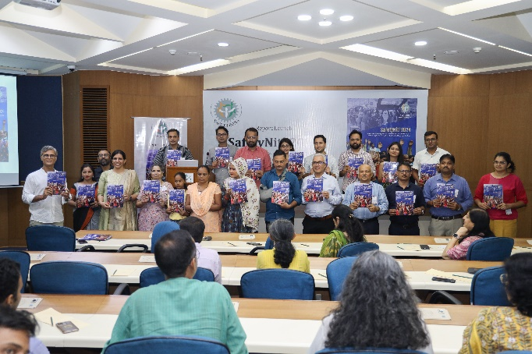

**Quotes from the Event**

1. Dr. Garima Dadhich Associate Professor, IICA, Ministry of Corporate Affairs
2. These guidelines (NGRBC) are endorsed by our honourable Prime Minister and the former FM as well, which means that there is a sincere appeal to the businesses to follow these guidelines.
3. Through the NGRBC, we are trying to make an impact on the board of directors of companies, to get them to understand that the long-term sustainability of the business, by earning the trust of the community, will impact their production and their profits.
4. The BRSR is for the top 1000 listed companies, but if we look at the parent document, the NGRBC, it is applicable irrespective of whether you are listed or unlisted, small or big.
5. Deepika Rao, Executive Director, CIVIDEP India
6. The business and government case for bringing about the guidelines is quite clear. The legislations across the world are moving increasingly towards regulations of the supply chain. We are seeing movement happening across the world – Europe, Australia, the UK, the US and other countries, all of them have their laws on supply chain transparency, due diligence and regulations.
7. From CIVIDEP’s work in the textile sector, we are able to see that a large part of the violations that are taking place in the shop floor can be easily connected to the practices of multinational corporations. In fast fashion, we have tracked 7 indicators linking contracting and purchasing practices of brands to workplace rights violations on the shop floor.
8. Sonvi Khanna, Associate Director, Social Compact, Dasra
9. The ownership of OSH has to be a shared ownership between the principal company (the brand) and the supplier. The Supplier Codes of Conduct should not be blindly signed. But rather a dialogue has to be held with the supplier to see what is going to deter the acceptance and following of this, what is going to enable this and what would be the need from the principal company.
10. The safety of the informal workforce in the supply chain is not an agenda item of the board and may not interest them. The only indicator (information) that goes up is near misses and accidents. But anything less serious than that, for example, procedure failures, any big departures from the manuals etc. don’t.
11. On the day the inspections happen, everything looks hunky dory. Something has to happen on a day different from the “monitoring day”.
12. Neetu Devi, Injured Worker
13. The power press didn’t have the required safety systems. It could be operated with one hand and didn’t require both hands to be outside. If it had the required safety device, my hand wouldn’t have been cut.
14. Gajendra, Injured Worker
15. The Plant Head and the Production Manager, under production pressure had disabled the sensor. And that’s why the accident happened.
16. The factory I worked at, made parts for Maruti Suzuki and Honda. Tools have the brand names stamped and that’s how we know.
17. Basanti, Injured Worker
18. The factory manufactured parts for Maruti. When there were delays, the supervisor used to mention that Maruti’s delivery was delayed. By chance, if there is a visit, they mention that it is Maruti’s visit, and they ask us to keep the factory clean and we are made to wear shoes, gloves and earplugs.
19. Sandeep Sachdeva, Co-Founder & CEO, Safe In India.
20. Nine of the top 10 brands are now engaging with us to varying degrees. Mahindra & Mahindra and TVS joined this list this year. Only Ashok Leyland is now being evasive. Let’s hope they see the light soon enough. We are also grateful that almost all of them have improved several of their worker safety policies since our first policy report – SafetyNiti 2021. Implementation of policies still lags.
21. In my meetings with Bangladesh garment factory owners, I have found them much more professional than our equivalent-sized Tier 2 factories in the auto sector. These owners told me that Rana Plaza was good for their business as they had to quickly learn to improve their processes and professionalise their operations.
22. V N Saroja, Senior Advisor, Safe In India
23. 50 years ago, balance sheets were not formalised or standardised. Non-financial reporting will also progress similarly with everyone reaching the same stage of transparency.

**About Safe In India**

A 2014 news story titled “How Indian cars are built on an assembly of crushed fingers” shocked and inspired 3 IIM Ahmedabad alumni to set up the Safe In India Foundation. Over the years, SII has worked on four fronts: assistance to injured workers for ESIC healthcare and compensation; advocacy with industry and government for better workplace safety and better ESIC services; communication for better awareness among workers, industry and other stakeholders on worker safety and ESIC practices.

**SII has assisted 8000+ injured workers, helping deliver Rs 85 crores + in ESIC compensation.**

SII releases two annual reports each year. SafetyNiti reports the progress or gaps in automobile brands’ policies and codes of conduct, while CRUSHED (CRUSHED 2024 will be released in November 2024) presents on-ground data and analysis of worker accidents, their reasons, and recommendations on how to evolve worker safety across the supply chain.

For more information, please get in touch with us at [team@safeinindia.org](mailto:team@safeinindia.org). For queries related to SafetyNiti 2024, and additional details and pictures, please get in touch with Dhanraj at [dhanraj.safeinindia@gmail.com](mailto:dhanraj.safeinindia@gmail.com) and +91 8123 955 150

**Contact Persons**

Sandeep Sachdeva, Co-Founder & CEO, SII, at [sandeep.sachdeva.safeinindia@gmail.com](mailto:sandeep.sachdeva.safeinindia@gmail.com)   
  
V N Saroja, Head of Safety, SII, at [vn.saroja.safeinindia@gmail.com](mailto:vn.saroja.safeinindia@gmail.com)

Dhanraj B at [dhanraj.safeinindia@gmail.com](mailto:dhanraj.safeinindia@gmail.com)